- NAME OF THE MEDICINAL PRODUCT
IBUPROFEN TABLETS B.P. 400 MG
2. QUALITATIVE AND QUANTITATIVE COMPOSITION
Each -coated tablet contains 400 mg ibuprofen .
For the full list of excipients, see section 6.1.
3. PHARMACEUTICAL FORM
coated tablet.
ORANGE CAPLET SHAPE COATED TABLETS WITH IBU-400 PRINTED ON IT..
4. CLINICAL PARTICULARS
4.1 Therapeutic indications
Is indicated in adults for the short term treatment of acute moderate pain.
4.2 Posology and method of administration
Posology
For acute moderate pain a single administration of one 1 coated tablet (400 mg
Ibuprofen is recommended. Dosing may be repeated after 6-8 hours, without exceeding
a maximum daily dose of 1,200 mg ibuprofen (3 tablets daily). Treatment duration
should not exceed 3 days.
For mild pain conditions or when treatment duration exceeds 3 days, is not recommended.
Single-agent therapy should be considered in the lowest effective dose e.g. Ibuprofen 200 mg.
For short-term use only.
Undesirable effects may be minimised by using the lowest effective dose for the shortest duration necessary
to control symptoms (see section 4.4).
It is recommended that patients with sensitive stomachs take with food.
If taken shortly after eating, the onset of actions of may be delayed. If this happens do not
take more than recommended or until the correct re-dosing interval (6 to 8 hours) has
passed.
Elderly
No clinical studies have been performed in elderly thus no special dose recommendations can be given. As
elderly patients are at higher risk of experiencing adverse reactions to NSAIDs and/ or caffeine (see section
4.4), it is recommended to monitor the elderly particularly carefully.
Renal impairment
No dose adjustment is required in patients with mild to moderate impairment of renal function (for patients
with severe renal insufficiency see section 4.3).
3
Hepatic impairment
No dose adjustment is required in patients with mild to moderate impairment of hepatic function (for patients
with severe hepatic dysfunction see section 4.3).
Paediatric population is contraindicated in children and adolescents below the age of 18 years (see section 4.3).
Method of administration
is for oral use.
The tablets should be swallowed whole with a glass of water.
4.3 Contraindications
- Hypersensitivity to the active substances or to any of the excipients listed in section 6.1.
- History of hypersensitivity reactions (e.g. bronchospasm, asthma, rhinitis, angioedema or urticaria)
associated with the intake of acetylsalicylic acid or other non-steroidal anti-inflammatory drugs
(NSAIDs).
- Children and adolescents below the age of 18 years.
- Unclarified blood-formation disorders.
- Active, or history of recurrent or existing peptic ulcer/haemorrhages (two or more distinct episodes of
proven ulceration or bleeding).
- History of gastrointestinal bleeding or perforation, related to previous NSAIDs therapy.
- Cerebrovascular or other active bleeding.
- Severe heart failure (NYHA Class IV) (see also section 4.4).
- Severe hepatic failure, severe renal failure (see also section 4.4).
- Third trimester of pregnancy (see section 4.6).
- Severe dehydration (caused by vomiting, diarrhoea or insufficient fluid intake).
4.4 Special warnings and precautions for use
Undesirable effects may be minimised by using the lowest effective dose for the shortest duration necessary
to control symptoms (see gastrointestinal and cardiovascular risks below).
Caution is required in patients with certain conditions, which may be made worse:
- systemic lupus erythematosus and mixed connective tissue disease – increased risk of aseptic
meningitis (see section 4.8).
- congenital disorder of porphyrin metabolism (e.g. acute intermittent porphyria).
- gastrointestinal disorders and chronic inflammatory intestinal disease (e.g. ulcerative colitis, Crohn’s
disease) (see section 4.8).
- hypertension and/or cardiac impairment as renal function may deteriorate (see sections 4.3 and 4.8).
- renal impairment (see sections 4.3 and 4.8).
- hepatic dysfunction (see sections 4.3 and 4.8).
- directly after major surgery.
- in patients with an allergic disposition to other substances, as they may be susceptible to develop
hypersensitivy reactions towards ibuprofen as well.
- in patients who suffer from hayfever, nasal polyps or chronic obstructive respiratory disorders, as
these patients are at an increased risk of allergic reactions. These may present as asthma attacks (socalled analgesic asthma), Quincke’s oedema or urticaria.
Gastrointestinal (GI) effects
The use of with concomitant NSAIDs including cyclooxygenase-2 selective inhibitors,
increases the risk of adverse reactions (see section 4.5) and should be avoided.
Gastrointestinal bleeding, ulceration or perforation, which can be fatal, have been reported with all NSAIDs
at any time during treatment, with or without warning symptoms or a previous history of GI events.
4
When GI bleeding or ulceration occurs in patients receiving ibuprofen, it is advised to withdraw the
treatment.
The risk of GI bleeding, ulceration or perforation is higher with increasing NSAID doses, in patients with a
history of ulcer, particularly if complicated with haemorrhage or perforation, and in the elderly. These
patients should commence treatment on the lowest dose available. Combination therapy with protective
agents (e.g. misoprostol or proton pump inhibitors) should be considered for these patients, and also for
patients requiring concomitant low-dose acetylsalicylic acid, or other medicinal products likely to increase
GI risk (see below and section 4.5).
The patient is to be instructed to withdraw the medicinal product and to consult a physician immediately if
severe pain in the upper abdomen or melaena or haematemesis occurs. Patients with a history of GI toxicity,
particularly the elderly, should be advised to report any unusual abdominal symptoms (especially GI
bleeding) particularly in the initial stages of treatment.
Caution should be advised in patients receiving concomitant medications which could increase the risk of
ulceration or bleeding, such as oral corticosteroids, anticoagulants such as warfarin, selective serotoninreuptake inhibitors or anti-platelet agents such as acetylsalicylic acid (see section 4.5).
NSAIDs should be given with care to patients with a history of GI disease (e.g. ulcerative colitis, Crohn’s
disease) as their condition may be exacerbated (see section 4.8).
Severe skin reactions
Serious skin reactions, some of them fatal, including exfoliative dermatitis, Stevens-Johnson syndrome and
toxic epidermal necrolysis, have been reported very rarely in association with the use of NSAIDSs (see
section 4.8). Patients appear to be at highest risk of these reactions early in the course of therapy, the onset of
the reaction occurring in the majority of cases within the first month of treatment. Acute generalised
exanthematous pustulosis (AGEP) has been reported in relation to ibuprofen-containing products. <Invented
name> should be discontinued at the first appearance of skin rash, mucosal lesions, or any other sign of
hypersensitivity.
Exceptionally, varicella may be associated with the onset of serious cutaneous and soft tissue infectious
complications. Due to the potential of NSAIDs to worsen these infections, it is advisable to avoid use of
ibuprofen in case of varicella.
Cardiovascular and cerebrovascular effects
Caution is required prior to starting treatment in patients with a history of hypertension and/or heart failure as
fluid retention, hypertension and oedema have been reported in association with NSAID therapy.
Clinical studies suggest that use of ibuprofen, particularly at a high dose (2400 mg/day) may be associated
with a small increased risk of arterial thrombotic events (for example myocardial infarction or stroke).
Overall, epidemiological studies do not suggest that low dose ibuprofen (e.g.,  1200mg/day) is associated
with an increased risk of arterial thrombotic events.
Patients with uncontrolled hypertension, congestive heart failure (NYHA II-III), established ischaemic heart
disease, peripheral arterial disease, and/or cerebrovascular disease should only be treated with ibuprofen after
careful consideration and high doses (2400 mg/day) should be avoided.
Careful consideration should also be exercised before initiating longer-term treatment of patients with risk
factors for cardiovascular events (e.g. hypertension, hyperlipidaemia, diabetes mellitus, smoking),
particularly if high doses of ibuprofen (2400 mg/day) are required.
Hypersensitivity
Severe acute hypersensitivity reactions (e.g. anaphylactic shock) are observed very rarely. At the first signs
of hypersensitivity reaction (e.g. facial oedema, angioedema, dyspnoea, tachycardia, drop in blood pressure,
5
anaphylactic shock) after taking/administering therapy must be stopped. The patient should
be advised to immediately seek the assistance of a physician.
Effects on liver, renal and blood parameters
Ibuprofen may temporarily inhibit the blood-platelet function (thrombocyte aggregation). Therefore, patients
with platelet disorders should be monitored carefully.
In case of prolonged treatment with ibuprofen, liver and kidney as well as blood parameters need to be
checked regularly. First signs of haematopoietic disorders may be fever, sore throat, superficial wounds in
the mouth, influenza-like complaints, severe lassitude, nosebleeds and skin bleeding.
Prolonged use of analgesics
Prolonged use of any type of analgesic for headaches can make them worse. If this situation is experienced
or suspected, treatment should be discontinued. The diagnosis of medication overuse headache should be
suspected in patients who have frequent or daily headaches despite (or because of) the regular use of
headache medications.
Concomitant alcohol consumption
Through concomitant consumption of alcohol, active substance-related undesirable effects, particularly those
that concern the gastrointestinal tract or the central nervous system, may be increased on use of NSAIDs.
Caffeine
Excessive intake of caffeine (e.g. coffee, tea, foods, other drugs and beverages) should be avoided while
taking this product (see section 4.9).
Particular caution is called for when using caffeine in patients with hyperthyroidism (risk of caffeine side
effects) or arrhythmias.
Specific populations
Elderly patients are at higher risk of experiencing adverse reactions to NSAIDs especially GI bleeding and
perforation, which may be fatal.
In the initial stages of treatment, careful monitoring of urine output and renal function is required in patients
with heart failure, patients with chronically impaired renal or hepatic function, patients taking diuretics,
patients who are hypovolaemic as a result of major surgery and, in particular, elderly patients.
This medicine contains less than 1 mmol sodium (23 mg) per tablet, that is to say essentially `sodium-free'.
4.5 Interaction with other medicinal products and other forms of interaction
Concomitant use of ibuprofen with: Possible effects:
Other NSAIDs, including salicylates: The concomitant administration of several NSAIDs may increase
the risk of gastrointestinal ulcers and bleeding due to a synergistic
effect. The concomitant use of ibuprofen with other NSAIDs
should therefore be avoided (see section 4.4).
Digoxin: The concomitant use of ibuprofen with digoxin preparations may
increase serum levels of these medicinal products. A check of
serum-digoxin is not required if used as recommended (maximum
over 3 days).
Corticosteroids: Corticosteroids may increase the risk of adverse reactions,
especially of the gastrointestinal tract (e.g. gastrointestinal
ulceration or bleeding) (see section 4.4).
Anti-platelet agents: Increased risk of gastrointestinal bleeding (see section 4.4).
6
Acetylsalicylic acid: Concomitant administration of ibuprofen and acetylsalicylic acid
is not generally recommended because of the potential of
increased adverse effects.
Experimental data suggest that ibuprofen may competitively
inhibit the effect of low dose acetylsalicylic acid on platelet
aggregation when they are dosed concomitantly. Although there
are uncertainties regarding extrapolation of these data to the
clinical situation, the possibility that regular, long-term use of
ibuprofen may reduce the cardioprotective effect of low-dose
acetylsalicylic acid cannot be excluded. No clinically relevant
effect is considered to be likely for occasional ibuprofen use (see
section 5.1).
Anticoagulants: NSAIDs may enhance the effect of anti-coagulants (see section
4.4).
Phenytoin: The concomitant use of ibuprofen with phenytoin preparations
may increase serum levels of these medicinal products. A check of
serum-phenytoin levels is not required if used as recommended
(maximum over 3 days).
Selective serotonin reuptake inhibitors
(SSRIs):
Increased risk of gastrointestinal bleeding (see section 4.4).
Lithium: The concomitant use of ibuprofen with lithium preparations may
increase serum levels of these medicinal products. A check of
serum-lithium is not required if used as recommended (maximum
over 5 days).
Probenecid and sulfinpyrazone: Medicinal products that contain probenecid or sulfinpyrazone may
delay the excretion of ibuprofen.
Diuretics, ACE inhibitors,
betareceptor-blockers and angiotensinII antagonists:
NSAIDs may reduce the effect of diuretics and other
antihypertensive medicinal products. In some patients with
compromised renal function (e.g. dehydrated patients or elderly
patients with compromised renal function) the co-administration of
an ACE inhibitor, betareceptor-blockers or angiotensin-II
antagonists and agents that inhibit cyclo-oxygenase may result in
further deterioration of renal function, including possible acute
renal failure, which is usually reversible. Therefore, the
combination should be administered with caution, especially in the
elderly. Patients should be adequately hydrated and consideration
should be given to monitoring of renal function after initiation of
concomitant therapy, and periodically thereafter.
Potassium sparing diuretics: The concomitant administration of ibuprofen and potassiumsparing diuretics may lead to hyperkalaemia. Check of serum
potassium is recommended.
Methotrexate: The administration of ibuprofen within 24 hours before or after
administration of methotrexate may lead to elevated
concentrations of methotrexate and an increase in its toxic effect.
Ciclosporin: The risk of a kidney-damaging effect due to ciclosporin is
increased through the concomitant administration of certain
nonsteroidal antiinflammatory drugs. This effect may also be
relevant for a combination of ciclosporin with ibuprofen.
7
Tacrolimus: The risk of nephrotoxicity is increased if the two medicinal
products are administered concomitantly.
Zidovudine: There is evidence of an increased risk of haemarthroses and
haematoma in HIV (+) haemophiliacs receiving concurrent
treatment with zidovudine and ibuprofen.
Sulphonylureas: Clinical investigations have shown interactions between
nonsteroidal anti-inflammatory drugs and antidiabetics
(sulphonylureas). Although interactions between ibuprofen and
sulphonylureas have not been described to date, a check of bloodglucose values is recommended as a precaution on concomitant
intake.
Quinolone antibiotics: Animal data indicate that NSAIDs can increase the risk of
convulsions associated with quinolone antibiotics. Patients taking
NSAIDs and quinolones may have an increased risk of developing
convulsions.
CYP2C9 inhibitors: Concomitant administration of ibuprofen with CYP2C9 inhibitors
may increase the exposure to ibuprofen (CYP2C9 substrate). In a
study with voriconazole and fluconazole (CYP2C9 inhibitors), an
increased S(+)-ibuprofen exposure by approximately 80 to 100 %
has been shown. Reduction of the ibuprofen dose should be
considered when potent CYP2C9 inhibitors are administered
concomitantly, particularly when high dose (2400 mg/day)
ibuprofen is administered with either voriconazole or fluconazole.
Mifepristone: NSAIDs should not be used for 8-12 days after mifepristone
administration as NSAIDs can reduce the effect of mifepristone.
Concomitant use of caffeine with: Possible effects:
Barbiturates, anti-histaminics and
other drugs with sedative effect:
Caffeine may antagonise the sedative effect.
Barbiturates and smoking: These increase the caffeine metabolism in the liver.
Sympathomimetics, thyroxin and
other drugs with tachycardic effect:
Co-administration may increase the tachycardic effect.
Oral contraceptives, cimetidine,
fluvoxamine and disulfiram:
Co-administration reduces the caffeine metabolism in the liver.
Theophylline: Caffeine reduces the excretion of theophylline.
Quinolone antibiotics: Co-administration can delay the elimination of caffeine.
4.6 Fertility, pregnancy and lactation
Pregnancy
Inhibition of prostaglandin synthesis may adversely affect the pregnancy and/or the embryonic/foetal
development. Data from epidemiological studies raise concern about an increased risk of miscarriage and of
cardiac malformation and gastroschisis after use of a prostaglandin synthesis inhibitor in early pregnancy.
The absolute risk for cardiovascular malformation was increased from less than 1%, up to approximately
1.5%. The risk is believed to increase with dose and duration of therapy.
8
In animals, administration of a prostaglandin synthesis inhibitor has been shown to result in increased
pre- and post-implantation loss and embryo-foetal lethality. In addition, increased incidences of various
malformations, including cardiovascular, have been reported in animals given a prostaglandin synthesis
inhibitor during the organogenetic period.
During the first and second trimester of pregnancy, ibuprofen is not recommended unless clearly
necessary. If ibuprofen is used by a woman attempting to conceive, or during the first and second
trimester of pregnancy, the dose should be kept as low and duration of treatment as short as possible.
During the third trimester of pregnancy, all prostaglandin synthesis inhibitors may expose
the foetus to:
- cardiopulmonary toxicity (with premature closure of the ductus arteriosus and pulmonary
hypertension)
- renal dysfunction, which may progress to renal failure with oligo-hydroamniosis
the mother and the neonate, at the end of pregnancy to:
- possible prolongation of bleeding time, an anti-aggregating effect which may occur even at very
low doses.
- inhibition of uterine contractions resulting in delayed or prolonged labour.
Consequently, is contraindicated during the third trimester of pregnancy (see section 4.3).
There is evidence that the prolonged intake of high amounts of caffeine may lead to spontaneous abortion or
premature birth in pregnant women. Non-clinical studies have shown reproductive toxicity at very high
doses.
Breastfeeding
Ibuprofen and its metabolites can pass in low concentrations into the breast milk. No harmful effects to
infants are known to date. Therefore, for short-term treatment with the recommended dose (see section 4.2),
interruption of breast-feeding would generally not be necessary.
Caffeine passes into breast milk and may influence the condition and behaviour of the infant. Irritability and
poor sleeping pattern in infants have been reported. should only be used by breast-feeding
mothers if clearly needed.
Fertility
There is some evidence that drugs which inhibit cyclo-oxygenase/ prostaglandin synthesis may cause
impairment of female fertility by an effect on ovulation. This is reversible on withdrawal of treatment.
4.7 Effects on ability to drive and use machines <Product name>
As central nervous undesirable effects such as tiredness, dizziness and visual disturbances may occur with
use of at high dosage, the ability to react and the ability to take part actively in road traffic
and to operate machines may be impaired in isolated cases. This applies to a greater extent in combination
with alcohol.
4.8 Undesirable effects
The list of the following undesirable effects comprises all undesirable effects that may occur under treatment
with ibuprofen, also those under high-dose long-term therapy in rheumatism patients.
9
For ibuprofen containing drug products the most commonly observed adverse reactions are gastrointestinal
in nature. Peptic ulcers, perforation or GI bleeding, sometimes fatal, particularly in the elderly may occur
(see section 4.4). Particularly the risk of gastrointestinal bleeding occurring is dependent on the dose range
and the duration of use.
Oedema, hypertension and cardiac failure have been reported in association with NSAID treatment.
Clinical studies suggest that use of ibuprofen, particularly at a high dose (2400 mg/day) may be associated
with a small increased risk of arterial thrombotic events (for example myocardial infarction or stroke) (see
section 4.4).
In one clinical trial investigating effect on pain after multimolar tooth extraction the
frequency of Alveolar osteitis was reported to be 2.8% and aphthous stomatitis as 1.4%.
Patients should be informed that they should stop taking immediately and consult a
physician if they experience a serious adverse drug reaction.
very common (≥1/10)
common (≥1/100 to <1/10)
uncommon (≥1/1,000 to <1/100)
rare (≥1/10,000 to <1/1,000)
very rare (<1/10,000)
not known (cannot be estimated from the available data)
System Organ Class Frequencies Side effect
Infections and
infestations
Very rare Exacerbation of infection-related inflammations (e.g.
development of necrotising fasciitis).2
Symptoms of aseptic meningitis (stiffness of the neck, headache,
nausea, vomiting, fever or disorientation) particularly in patients
with pre-existent autoimmune diseases (SLE, mixed connective
tissue disease).2
Blood and lymphatic
system disorders
Very rare Haematopoietic disorders (anaemia, leucopenia,
thrombocytopenia, pancytopenia, agranulocytosis).
2
Immune system
disorders
Uncommon Hypersensitivity reactions with skin rashes and itching and
asthma attacks (with drop in blood pressure).2
Very rare Severe generalised hypersensitivity reactions, signs may be
facial oedema, angioedema, dyspnoea, tachycardia, drop in
blood pressure, anaphylactic shock.2
Psychiatric disorders Uncommon Psychotic reactions1,2
Very rare Depression2
Nervous system
disorders
Common Dizziness1,2
, sleeplessness (insomnia)1,2,3
, headache4
Uncommon Central nervous disturbances such as agitation2
, irritability2 or
tiredness2
Not known Tremor3
Eye disorders Uncommon Visual disturbances2
Ear and labyrinth
disorders
Rare Tinnitus2
Cardiac disorders Uncommon Palpitations1,2
Very rare Heart failure2
, myocardial infarction2
Not known Tachycardia3
Vascular disorders Very rare Arterial hypertension2
, vasculitis
Gastrointestinal
disorders
Common Gastrointestinal complaints2,3 such as pyrosis2
, abdominal pain2
,
nausea1,2
, vomiting2
, flatulence2
, diarrhoea2
, constipation2
, minor
gastrointestinal blood loss in rare cases leading to anaemia2
Uncommon Gastrointestinal ulcers potentially with bleeding and/or
10
perforation; melaena, haematemesis, ulcerous stomatitis,
exacerbation of colitis and Crohn’s disease, gastritis (see
section 4.4)2
Very rare Oesophagitis2
, pancreatitis2
, intestinal diaphragm-like stricture2
Hepatobiliary
disorders
Very rare Hepatic dysfunction, hepatic damage, particularly in long-term
therapy, hepatic failure, acute hepatitis.2
Skin and
subcutaneous tissue
disorders
Very rare Bullous reactions such as Stevens-Johnson syndrome and toxic
epidermal necrolysis (Lyell syndrome), alopecia, severe skin
infections, soft-tissue complications in a varicella infection.2
Not known Acute generalised exanthematous pustulosis (AGEP)
Drug reaction with eosinophilia and systemic symptoms
(DRESS syndrome)
Photosensitivity reaction
Renal and urinary
disorders
Rare Kidney-tissue damage (papillary necrosis) and elevated uric acid
concentrations in the blood.2
Very rare Oedemas (particularly in patients with arterial hypertension or
renal insufficiency), nephrotic syndrome, interstitial nephritis,
acute renal insufficiency.2
1
Identified side effects of observed for the combination therapy with ibuprofen and caffeine
2
Identified side effects of ibuprofen based on EU ibuprofen SmPC
3
Identified side effects of caffeine, based on experience with other caffeine containing combination
products
4 Based on one clinical study with 282 patients
Reporting of suspected adverse reactions
Reporting suspected adverse reactions after authorisation of the medicinal product is important. It allows
continued monitoring of the benefit/risk balance of the medicinal product. Healthcare professionals are asked
to report any suspected adverse reactions via the national reporting system listed in Appendix V.
4.9 Overdose
Ibuprofen
The symptoms of overdose can include CNS-related symptoms such as headache, dizziness, lightheadedness and unconsciousness (also myoclonic convulsions in children), abdominal pain, nausea,
vomiting, gastrointestinal bleeding and hepatic and renal dysfunction but also hypotension, respiratory
depression and cyanosis. In serious poisoning metabolic acidosis may occur.
A specific antidote does not exist.
Caffeine
Symptoms of toxicity may occur at caffeine doses of 1 g (15 mg/kg) and above if the dose is taken over a
short period.
Early symptoms with acute caffeine poisoning are usually tremor and restlessness. These are followed by
nausea, vomiting, tachycardia and confusion. With serious intoxication, delirium, seizures, supraventricular
and ventricular tachyarrhythmias, hypokalaemia and hyperglycaemia may occur.
Management of overdose
The management should be symptomatic and supportive and include the maintenance of a clear airway and
monitoring of cardiac and vital signs until stable. Consider oral administration of activated charcoal, if the
patient presents within 1 hour of ingestion of a potentially toxic amount, or gastric lavage. CNS symptoms
and convulsions can be treated with benzodiazepines; supraventricular tachyarrhythmias can be controlled
using ß-blockers such as propranolol, administered intravenously.
11
5. PHARMACOLOGICAL PROPERTIES
5.1 Pharmacodynamic properties
Pharmacotherapeutic group: Anti-inflammatory and antirheumatic products, non-steroids; Propionic acid
derivatives
ATC code: M01AE51
Mechanism of action
Ibuprofen
Ibuprofen is a non-steroidal, anti-inflammatory drug (NSAID) that in the conventional animal experiment
inflammation models has proven to be effective via prostaglandin-synthesis inhibition.
Caffeine
Caffeine is a methylxanthine that has antinociceptive effects mainly through antagonism of adenosine
receptors and inhibition of PG synthesis.
Pharmacodynamic effects
Ibuprofen
In humans, ibuprofen reduces inflammatory-related pain, swellings and fever. Furthermore, ibuprofen
reversibly inhibits ADP- and collagen-induced platelet aggregation.
Experimental data suggests that ibuprofen may competitively inhibit the effect of low dose acetylsalicylic
acid on platelet aggregation when they are dosed concomitantly. Some pharmacodynamic studies show that
when single doses of ibuprofen 400 mg were taken within 8 h before or within 30 min after immediate
release acetylsalicylic acid dosing (81 mg), a decreased effect of acetylsalicylic acid on the formation of
thromboxane or platelet aggregation occurred. Although there are uncertainties regarding extrapolation of
these data to the clinical situation, the possibility that regular, long-term use of ibuprofen may reduce the
cardioprotective effect of low-dose acetylsalicylic acid cannot be excluded. No clinically relevant effect is
considered to be likely for occasional ibuprofen use (see section 4.5).
Caffeine
Caffeine is a mild stimulant and is used as an analgesic adjuvant.
Clinical efficacy and safety
A single-center, randomised, double-blind, two-stage, parallel, controlled trial including 562 patients with
acute moderate to severe pain after tooth extraction investigated the combination of ibuprofen 400 mg and
caffeine 100 mg compared to ibuprofen 400 mg alone, caffeine 100 mg alone and placebo. Patients treated
with the combination showed a statistically significant and clinically relevant enhanced reduction of pain
intensity (≥ 1 on the numerical rating scale NRS) compared to ibuprofen alone during the time interval 0,5-2
h. Up to four hours after administration the results were statistically significant, but the mean pain intensity
difference was below 1 on the NRS.
Ibuprofen plus caffeine demonstrated significantly shorter time to perceptible pain relief (55 min earlier
compared to ibuprofen alone).
In this trial safety and tolerability of the ibuprofen 400 mg plus caffeine 100 mg combination were
demonstrated for a treatment period of 5 days. The incidence of adverse events was numerically higher
compared to ibuprofen alone.
5.2 Pharmacokinetic properties
Ibuprofen
12
Absorption
Following oral administration, ibuprofen is almost completely absorbed from the gastrointestinal tract. After
oral doses 400-mg ibuprofen, peak plasma concentrations of 31.0 ± 17.2 µg/mL (Cmax) of ibuprofen were
achieved within a median time of 1.5-1.9 hours (tmax). Concomitant administration with food may delay tmax
about 2-fold. The geometric mean area under the concentration-time curve to the last measured point
(AUC0-t ±%gCV) has been calculated as 133.0 ± 22.2 µg/mL/h.
Distribution
Plasma-protein binding amounts to about 99%. The apparent volume of distribution of ibuprofen after oral
administration is about 0.1-0.2 L/kg. Ibuprofen can be transferred into human breast milk and its presence
decreases with the protein concentration and the duration of lactation. The relative infant dose of ibuprofen
has been quantified as ≤10%, which is considered to be safe even in preterm babies. Ibuprofen is expected to
cross the blood-brain and the blood-cerebrospinal fluid barriers.
In synovial fluid, stable concentrations of ibuprofen of 5-8 mg/L are found between 2 and 8 h after
administration. The synovial fluid Cmax is about one-third the Cmax in plasma.
Biotransformation
Biotransformation in the liver involves the conjugation of ibuprofen with glucuronic acid and oxidation
yielding two main inactive metabolites, 2-hydroxyibuprofen and carboxyibuprofen. The degradation of
ibuprofen is catalyzed by CYP2C9, CYP2C8 and CYP2C19.
Elimination
After 24 hours, 74.5% ± 9.6% of a 400-mg dose of ibuprofen is recovered in urine from which the amount of
free active ibuprofen represents about 8%. The elimination half-life in healthy individuals and those with
liver and kidney diseases is 1.8 - 3.5 hours. The apparent clearance of ibuprofen after oral administration is
about 0.05 – 0.1 L/h/kg.
Linearity/non-linearity
Linear pharmacokinetics of ibuprofen has been reported in the dose range of 200 to 400 mg.
Special populations
Elderly
It has been reported that the apparent clearance, apparent volume of distribution and the mean residence time
of ibuprofen in elderly people (65 to 85 years old) do not differ from those in young subjects (22 to 35 years
old).
Renal impairment
The half-life of ibuprofen during hemodialysis, i.e. 1.3-1.9 h, is in the range of that of the normal subjects.
The drug recovery resulting from hemodialysis represents a small fraction of the total ingested dose, i.e.
<4%. The nondialyzability of ibuprofen is probably attributed to its high protein binding. Uremic patients
may need longer time to achieve therapeutic concentrations, but require no dose adjustment. The elimination
half-life in elderly patients with renal impairment has been calculated as 3.25 h.
Hepatic impairment
Following oral administration, the hepatic dysfunction has no effect on the pharmacokinetic profile of
ibuprofen, i.e. AUC and t1/2. No dose adjustment is required.
Caffeine
Absorption
Caffeine is readily and completely absorbed with an absorption half-life of about 10 minutes, peak
concentrations are achieved at about 30 - 40 minutes.
Distribution
Caffeine distributes into most tissues, crosses the blood-brain barrier, the placenta and is excreted into breast
milk. Protein binding is relatively low (30 - 40%).
13
Biotransformation
Caffeine is metabolised almost completely in the liver to its main metabolites dimethylxanthines
paraxanthine, theobromine and theophylline. The main enzyme involved in the caffeine biotransformation is
CYP 1A2 accounting for more about 95% of the caffeine clearance.
Elimination
Elimination half-life is relatively variable (2-12 hours).
Caffeine and its metabolites (xanthin and uric acid derivatives) are excreted mainly renally (86% of dose
within 48 hours). Only 0.5% to 2% of the ingested caffeine administered is excreted untransformed in urine.
Combination of ibuprofen and caffeine
Under fasted conditions, the formulation of ibuprofen and caffeine has been demonstrated to be
bioequivalent to other formulations containing ibuprofen alone. The pharmacokinetic profile of caffeine
is not modified by the presence of ibuprofen or vice versa.
In fasted conditions (after an overnight fast (>=10h)), Cmax is lower (by 41.9%) and Tmax longer (1.88 h
vs 0.50 h) for ibuprofen from , compared to ibuprofen lysinate. The exposure was
equivalent between both products.
Under fed conditions, Cmax is higher (by 12.7%), and Tmax is shorter (1.25 h vs. 1.625 h) for ibuprofen
from , compared to an ibuprofen lysinate tablet from the reference drug product. The
exposure was equivalent between both products.
5.3 Preclinical safety data
Ibuprofen
The subchronic and chronic toxicity of ibuprofen in animal experiments was observed principally as
lesions and ulcerations in the gastrointestinal tract. In vitro and in vivo studies gave no clinically relevant
evidence of a mutagenic potential of ibuprofen. In studies in rats and mice no evidence of carcinogenic
effects of ibuprofen was found. Ibuprofen did not impair fertility in rats and studies in rabbits revealed
no evidence of teratogenicity. In rats, ibuprofen produced maternal and embryo-fetal toxicity as well as
an increase in incidence of skeletal variations at high oral dose levels (600 mg/kg/day). The incidence of
external variations rose at doses of 255 mg/kg/day and above. Experimental studies have demonstrated
that ibuprofen crosses the placenta. Data from different studies yielded inconsistent results, thus an
environmental risk for the aquatic environment especially to fish cannot be excluded for the ibuprofen.
Caffeine
Caffeine is not mutagenic but clastogenic and/or aneugenic in several relevant in vitro genotoxicity tests
with limited evidence in vivo. There is inadequate evidence for the carcinogenicity in experimental
animals and humans. Caffeine at maternotoxic doses has been reported to produce developmental
inhibition of the skeletal system and gross malformations in laboratory animals, which is caused by
maternal haemodynamic disorders. However, there is no evidence to support a teratogenic effect of
caffeine in humans. Caffeine at very high oral doses affected post implantation mortality and fertility
index in rats and mice. The clinical relevance of these effects on fertility parameters is unknown.
Ibuprofen/caffeine combination
In an oral 7-day repeat dose toxicity study in male rats once daily doses of ibuprofen/caffeine
combinations (120 mg/30 mg and 180 mg/45 mg per kg bw) were compared with the single components
ibuprofen (120 and 180 mg/kg bw) and (30 and 45 mg/kg bw) and with vehicle. Animal
exposure to ibuprofen and caffeine clearly exceeded the respective exposure in humans at the
recommended therapeutic dose. Compared with ibuprofen as a single agent, there was no indication of
unexpected toxicological lesions or a relevant increase in gastrointestinal toxicity for the
ibuprofen/caffeine-combination.
In a safety pharmacology study in dogs in which single doses of an ibuprofen/caffeine combination (50
mg/12.5 mg per kg bw) were compared with the single components ibuprofen (50 mg/kg bw) and
14
caffeine (12.5 mg/kg bw) and with vehicle and which included a telemetric evaluation of cardiovascular
effects, including effects on blood pressure, heart rate and electrocardiogram (ECG), the
ibuprofen/caffeine combination did not raise any safety concerns at a systemic exposure to ibuprofen and
caffeine which clearly exceeded the respective exposure in humans at the recommended therapeutic
dose. There was no evidence for a relevant pharmacodynamic interaction between caffeine and
ibuprofen.
6. PHARMACEUTICAL PARTICULARS
6.1 List of excipients
Tablet Core
Ibuprofen BP
Maize starch
Maize starch
Sodium methyl paraben
Sodium propyl paraben

Film-coating
COLOUR NOVO ORANGE CODE NO( 58505)
Talc
6.2 Incompatibilities
Not applicable.
6.3 Shelf life
4 years
6.4 Special precautions for storage
This medicinal product does not require any special storage conditions.
6.5 Nature and contents of container
10 TABLETS PACKE IN ALU –PVC BLISTER, PACKE, AND EACH BLISTER PACK IN MONO CARTON.
6.6 Special precautions for disposal
Any unused medicinal product or waste material should be disposed of in accordance with local
Requirements.
SOLE AGENT: - NCI PHARMACHEM INDUSTRIES.
LAGOS,NIGERIA.
NAFDAC Reg. NO. : A4-8220

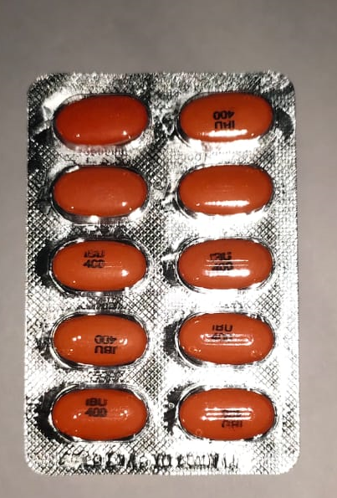

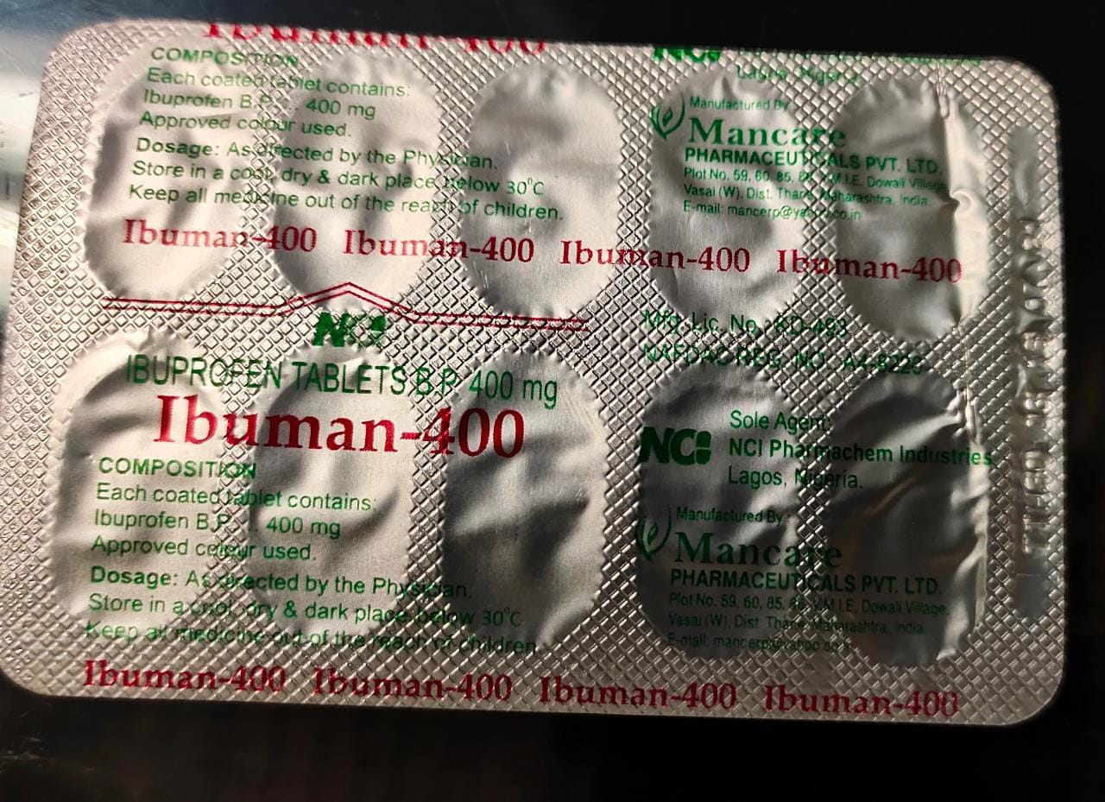
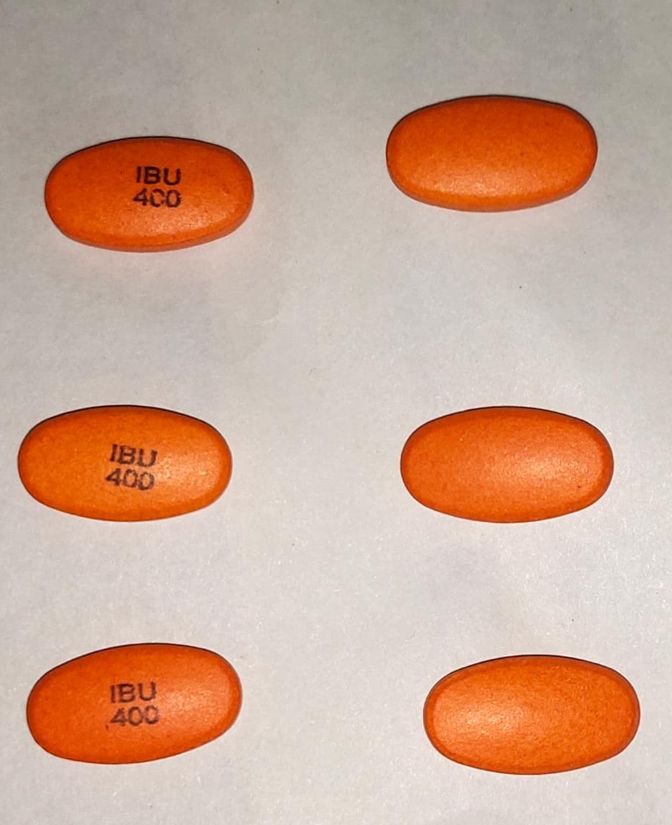

Z